


DO NOT ATTEMPT TO APPREHEND THE INDIVIDUALS LISTED HERE!
If you have current information about a subject’s whereabouts, call (585) 345-3000 extension 3577, email jbaiocco@co.genesee.ny.us or (585) 343-5000 to speak to a dispatcher. LAST UPDATED: April 24, 2014
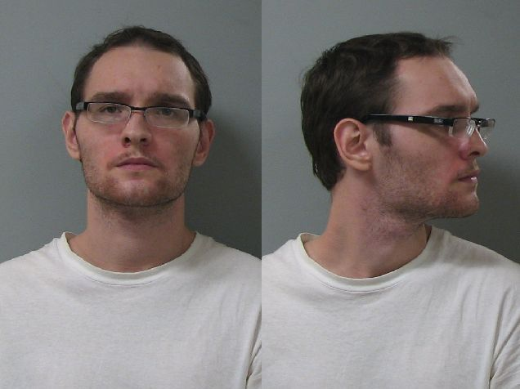 | 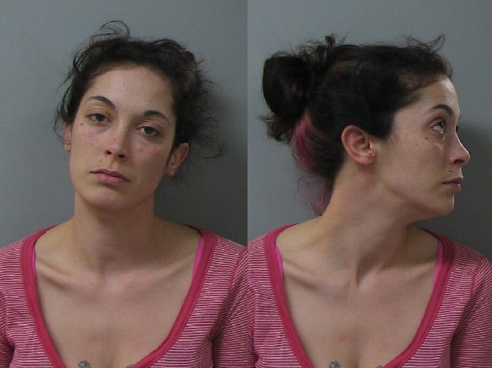 | 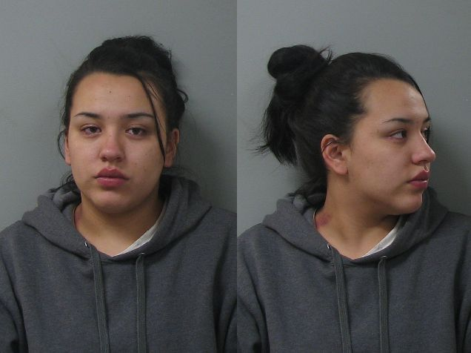
Antonio Michael Giglia | Jennifer Lynn Stack | Dora Lynn Poodry
Genesee County Court  Petit Larceny and Conspiracy 5th | Town of Batavia  Petit Larceny  3 Warrants | Genesee County Court  Violation of Probation  Bail Jumping 2nd

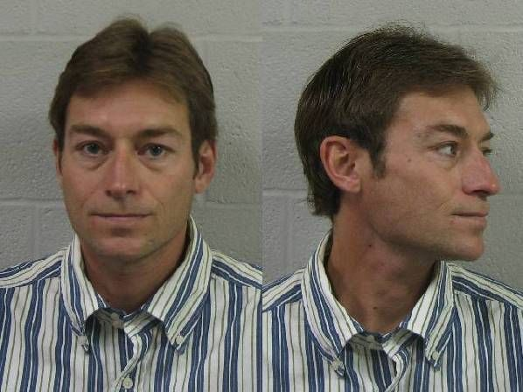 | 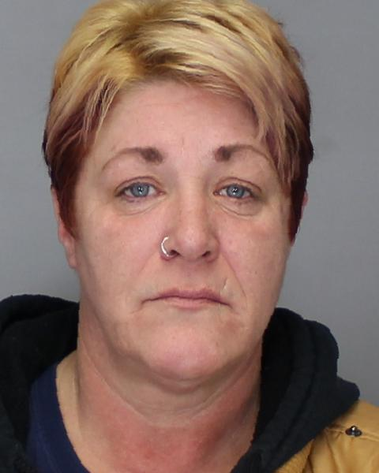 | 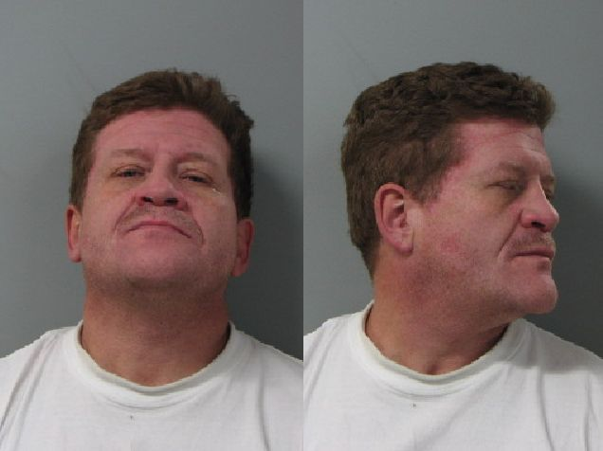
Rodney Phillip LaFramboise | Dawn L. Sedita | Clark Echevarria
Genesee County Court  Violation of Probation | Town of Alabama  Petit Larceny  Other Charges Pending | Town of Batavia  Petit Larceny
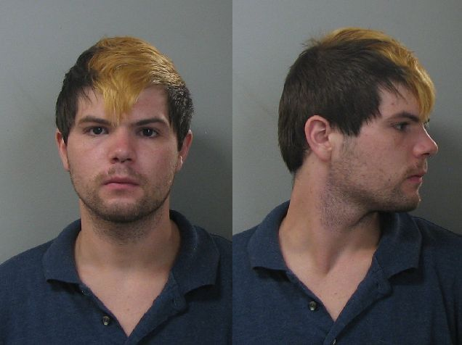 | 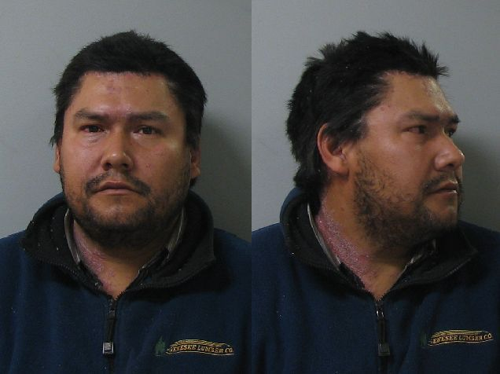 | 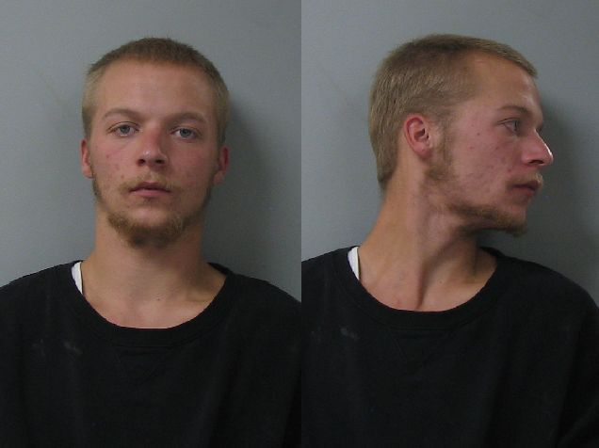
Kevin Albert Roberts | Guadalupe Hernandez | Christopher Charles Say
Town of Batavia  Criminal Mischief 3  Petit Larceny, UPM | Genesee Co Court – Att Burglary 2nd  Elba Town Court – DWI  Batavia City Court – Bail Jumping | IDV Court-Criminal Contempt 2  Criminal Obstruction of Breathing  Batavia City Court – Bail Jumping

